1. Register an account on Bloomberg Terminal at the 244 room at Van Pelt Library
2. Prepare a worksheet including all companies you need with ISIN code

* 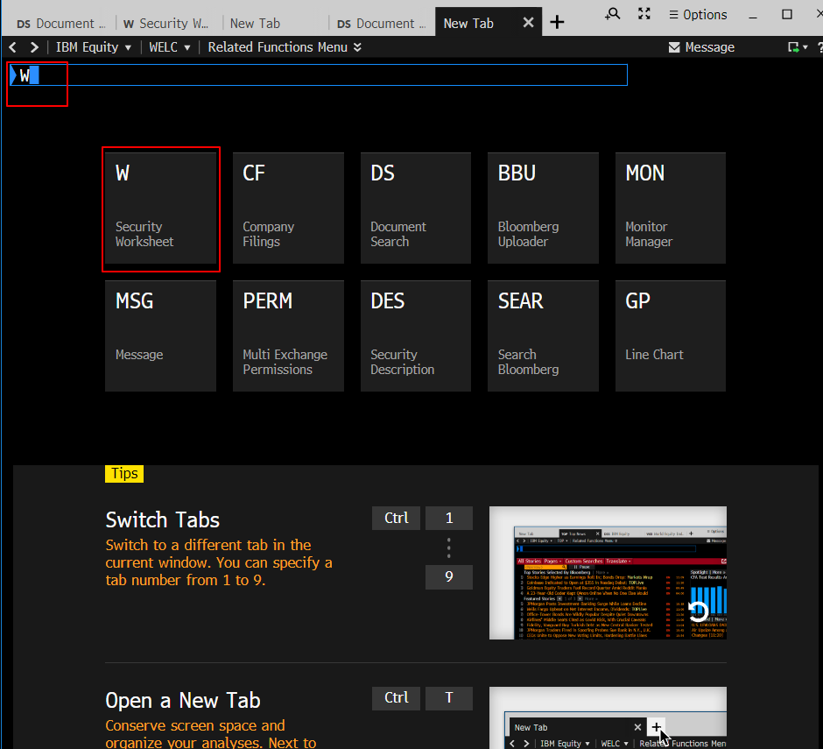Open a new tab and click Security Worksheet, or you can search W at the bar
* 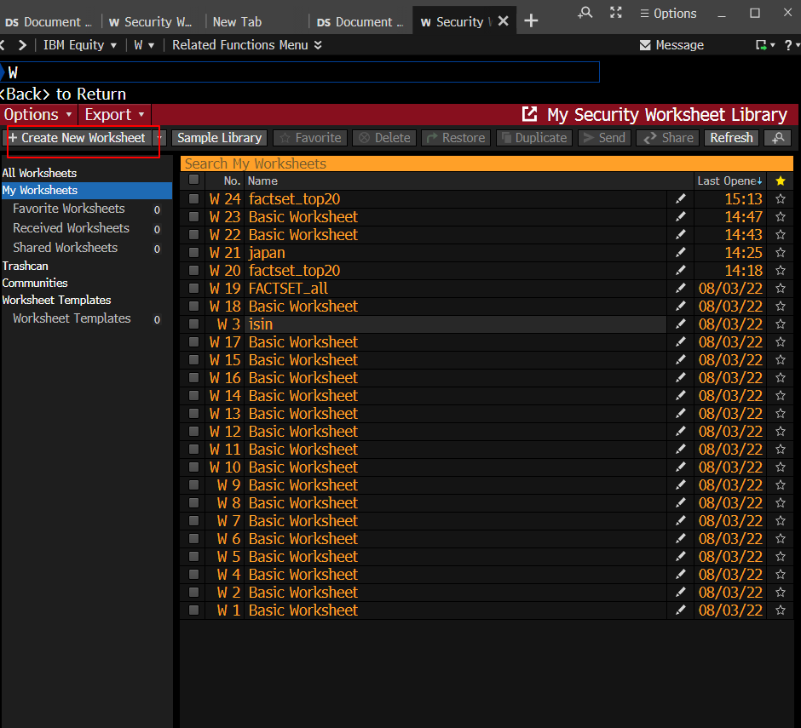Click ‘Create new Worksheet’
* 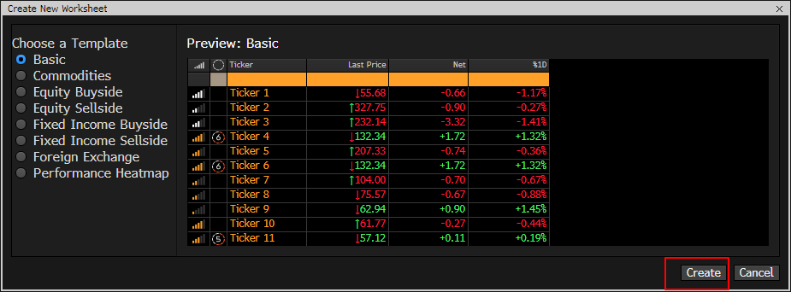Click “Create”
* Copy the ISIN number from the Excel and paste it to the Ticker column in the new BT worksheet
  + Tips: use **right click** instead of **ctrl+v** to paste on BT
  + 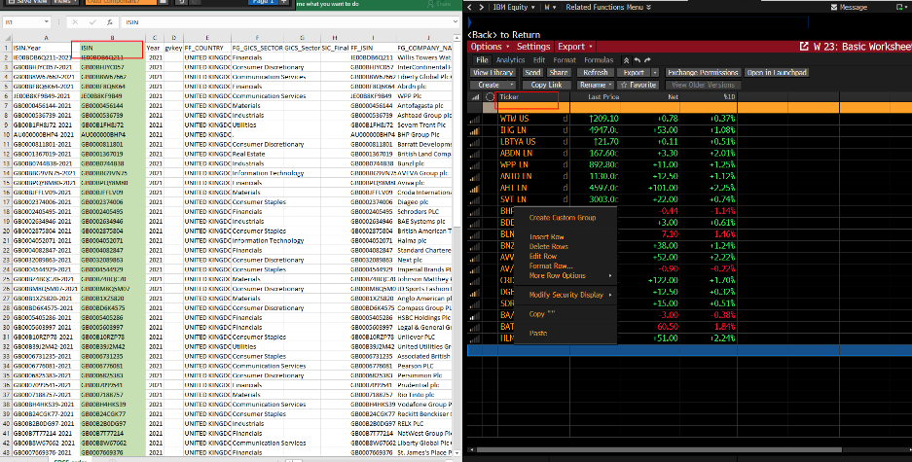Once you paste the ISIN number on BT, it will turn to Ticker automatically
* 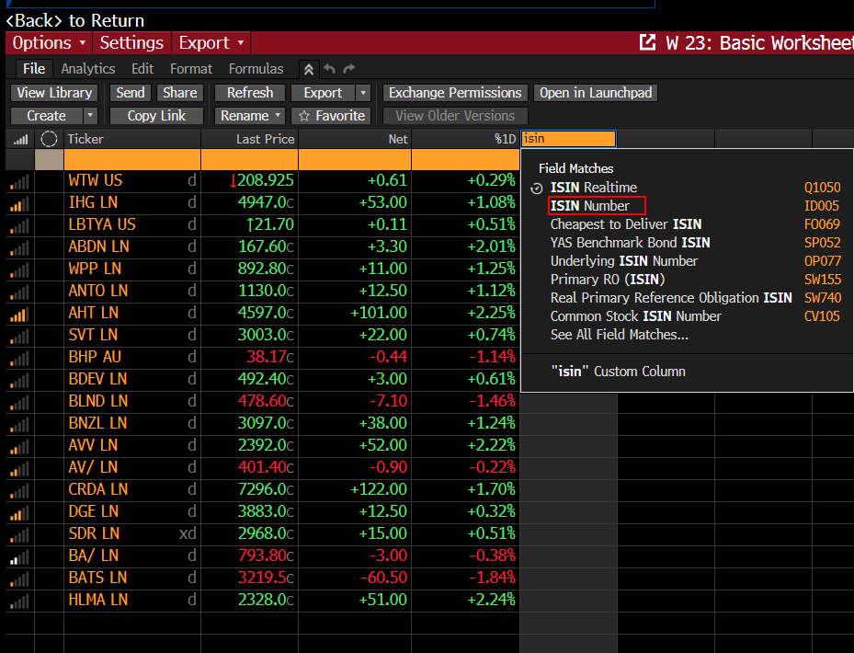Add an ISIN column by search if you need
* 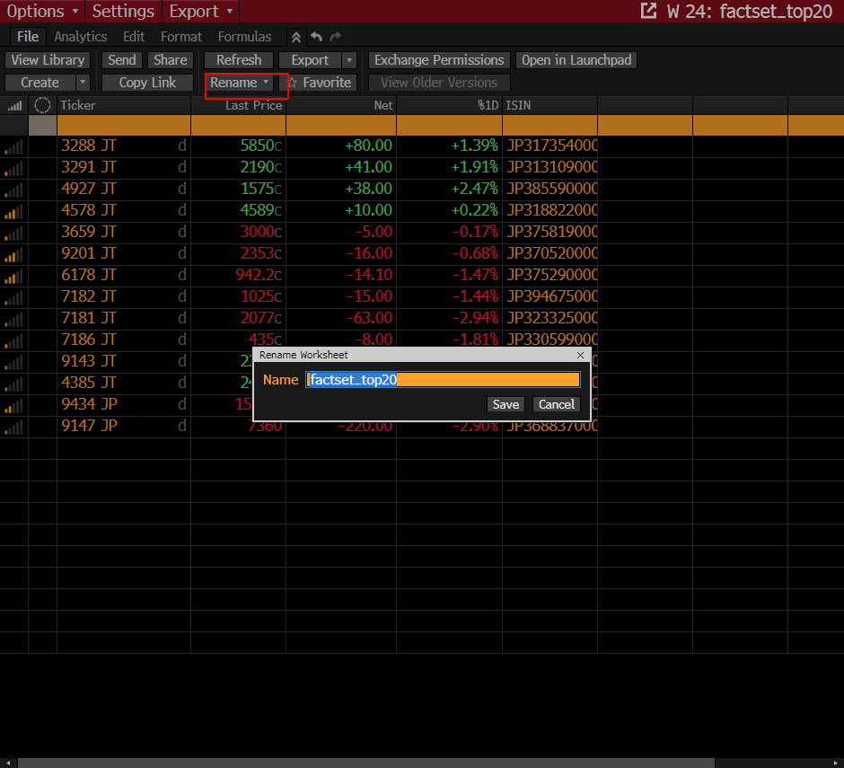Rename the file
* 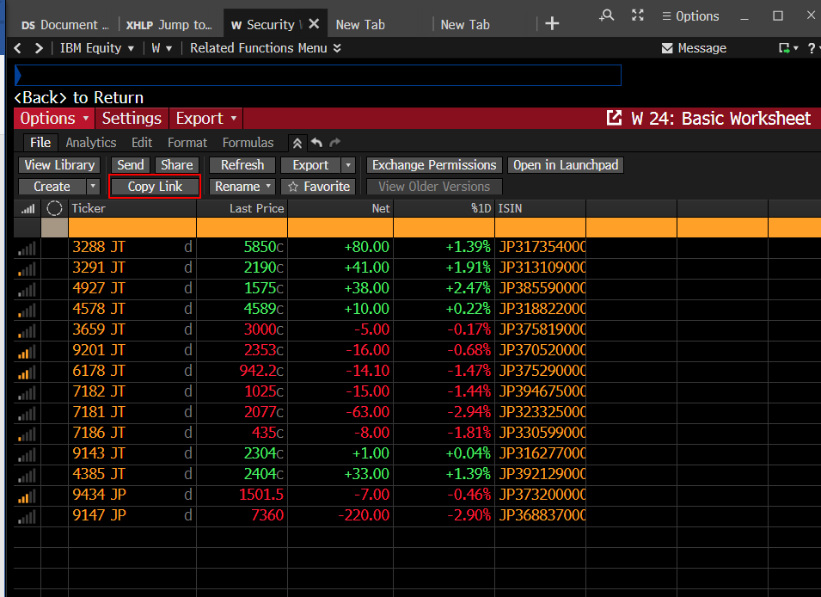Copy the link

1. Download the reports on Company Filings tab

* 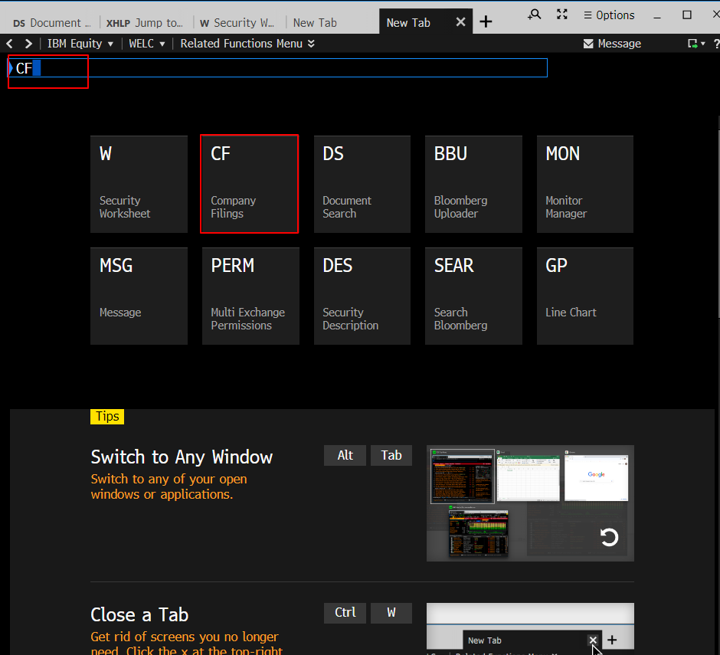Open a new tab and click company filings or search the CF in the bar
* Paste the link you copied on Security Worksheet tab to Securities/Lists bar, and click Browse Security Lists
  + 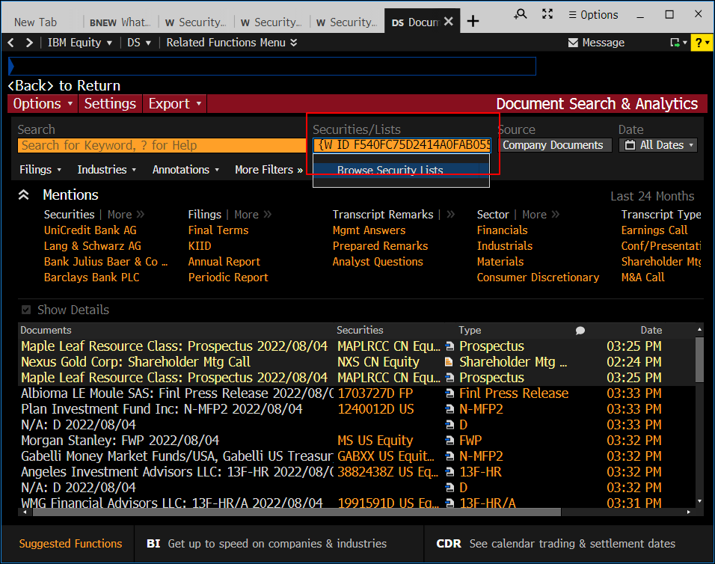Tip: use the **ctrl+v** to paste here
* choose the file you make
  + 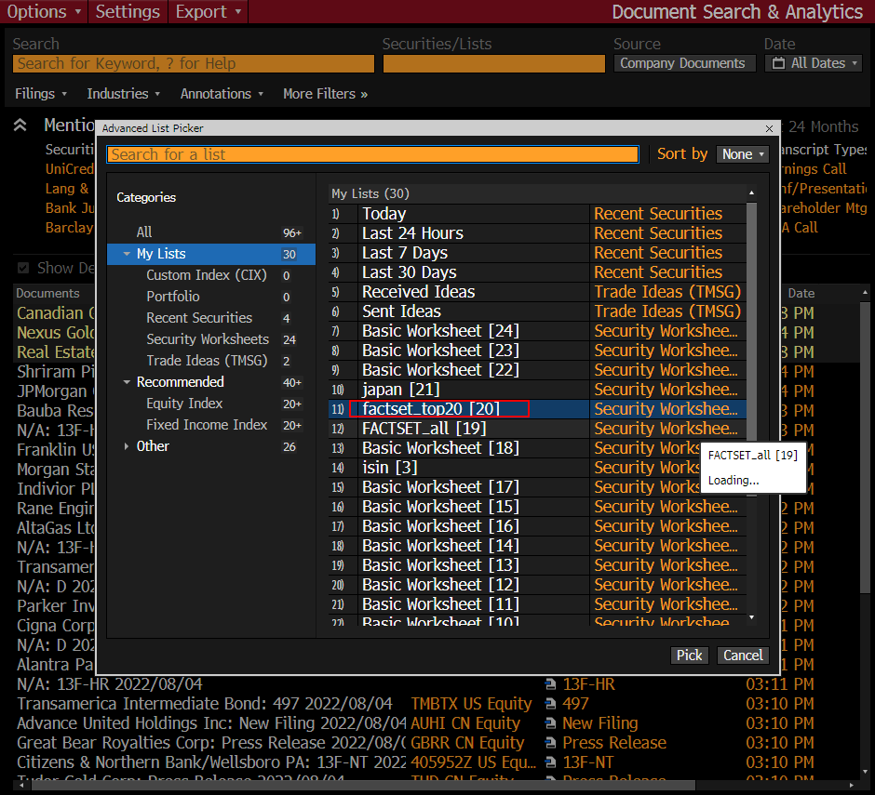Tips: it may take some time for the software process and show your table here
* 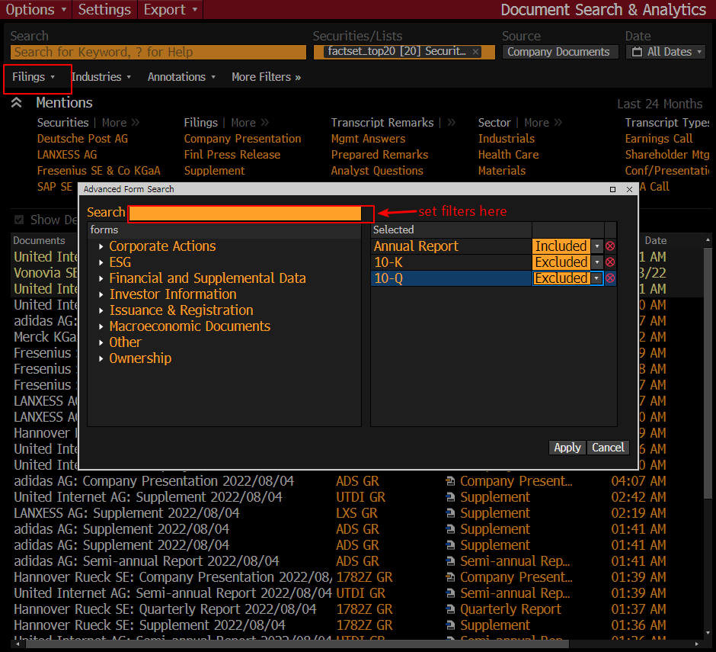Click Filings to set the filters for documents you want:
* 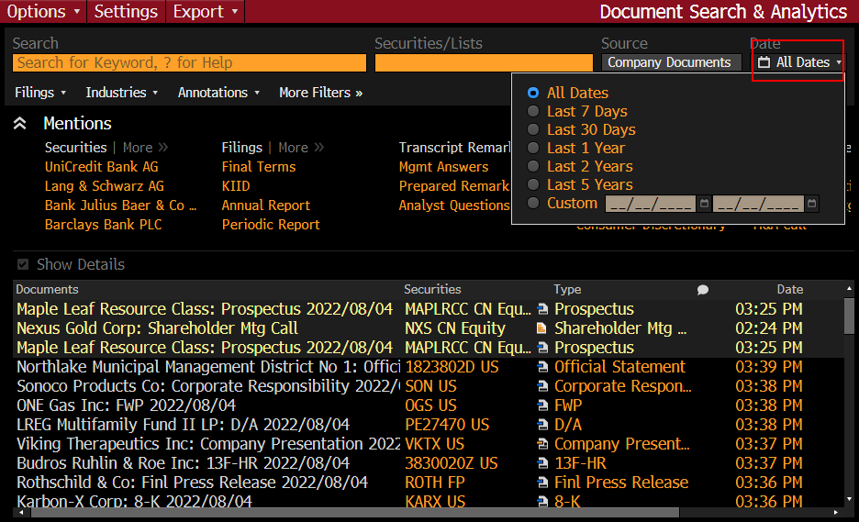Set date here
* 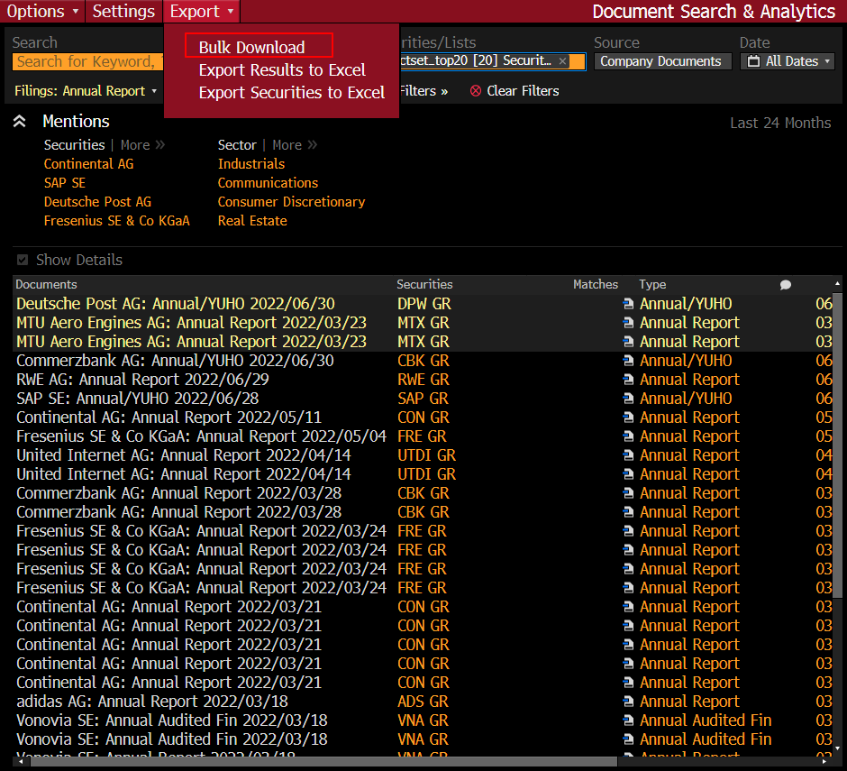Export